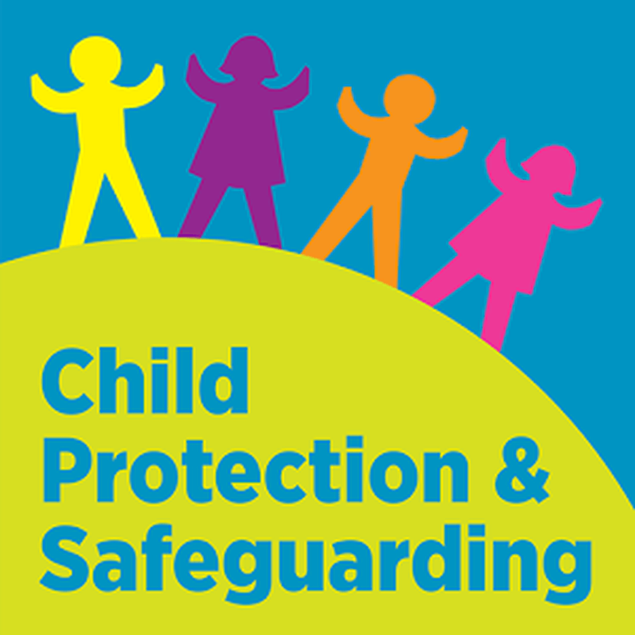
Safeguarding is everybody’s business! Everyone who cares for children and young people has a duty to safeguard their health and promote their welfare. All organisations that work with or come into contact with children should have safeguarding policies and procedures to ensure that every child, regardless of their age, disability, gender reassignment, race, religion or belief, sex, or sexual orientation, has a right to equal protection from harm. It is important that you know about the relevant legislation and how it applies to you in your role as a youth worker.

Following on from class discussions define the terms ‘child protection’ and’ safeguarding’? Demonstrate how the two link together.

Define the categories of abuse

Signs and symptoms of the 4 categories of abuse

What are the boundaries of confidentiality when working with young people? Refer to what your organisation policies say

Following on from class discussions make a list of child protection and safeguarding support agencies

How do you monitor, report and record child protection concerns in your setting? How do you store records?
If you were concerned about a young person or you felt a young person may be at risk of significant harm, who would you report this to in your organisation? Who is your designated safeguarding officer?

Outline safeguarding legislation, guidelines, policies and procedures that are relevant to your setting or organisation. List them out and explain a little bit about them.

What policies and procedures does your organisation have in place that promotes safeguarding or contributes to keeping young people safe?

How do your organisations policies and procedures regarding safeguarding and child protection influence your practice? – What are your specific responsibilities to child protection and safeguarding?

How do youth workers protect and support young people?

How do you help young people manage personal risk?

Describe how the purposes and principles of youth work align with safeguarding policies and procedures.

What types of challenges might you face when implementing your workplaces safeguarding procedures?

This will provide evidence you can:
  - Define the terms ‘safeguarding’ and ‘child protection’
  - Outline safeguarding legislation, guidelines, policies and procedures relevant to own organisation
  - Outline own organisation’s child protection policies and procedures that create a safe, but challenging environment that benefits young people
  - Describe how own organisation’s child protection policies and procedures influence own practice
  - Describe the boundaries of confidentiality when working with young people and how this could affect own rights
3.1 Identify a range of child protection and safeguarding support agencies
3.2 Describe forms of abuse and their characteristics
3.3 Identify own organisation’s safeguarding office I relation to reporting child protection issues
5.1 Describe how youth workers protect and support young people
5.2 Describe how the purposes and principles of youth work align with safeguarding policies and procedures
5.3 Outline ways to support and empower young people to manage personal risk
54. Outline the challenges when implementing safeguarding procedures in a youth work setting

