Course Title:-

Name of Learner:-

Name of Tutor: -

What is an individual learning plan and why is it important?
An individual learning plan is a record of your long and short term goals for this learning journey. It provides a format for you to track your progress throughout the course and identify any support needs you may have along the way.
Setting goals is an important part of the learning process as it gives you a direction and an aim and it helps keep you motivated.
Reviewing your progress towards these goals allows you to celebrate your achievements and identify any barriers that are getting in the way.

How to set yourself goals
You need to think about setting SMART goals for yourself.

Specific – make sure they are not vague or general goals
Measurable – Make sure you can recognise when you have achieved them
Achievable – ensure the goals you set are realistic
Relevant – Make sure the goals are relevant to your learning journey and work life
Time bound – ensure they are achievable in the time frame of the course

How will the individual learning plan be used?
You will be asked to complete an individual learning plan early on in the course and then at various points it will be reviewed.
Through completion and maintenance of this document you will gain an insight into its value to you and also how you may be able to use it as a tool with young people you work with as a way of monitoring and recording their progress.

The individual learning plan is an ‘active’ document and should be viewed as such. For example, your personal learning goals may change during the course and it is on this document that you can keep an up to date record of your progress.

An important aspect of any ILP is the opportunity for reflection and review of any targets set. There will be points during your learning journey that you will have the opportunity to see if you have achieved any of your learning targets and adjust your document as a result.

You may also find it useful to take your ILP to meetings with your supervisor and perhaps use it in your tutorial sessions with your course tutor.

Where are you now in terms of your youth work? Who do you work with, how many sessions do you do?

Where would you like to be in terms of your career in the next 3 years?

What are your reasons for coming on the course?

Outline 3 goals you have for your learning journey on the course – make sure they are SMART goals – they can be long term and/or short term goals.

Outline what you think might get in the way of you achieving these goals.

Use the wheel of youth work below to grade yourself on how confident, knowledgeable and experienced you feel you are in each area. This will help you think about learning targets and goals you may want to set for yourself.

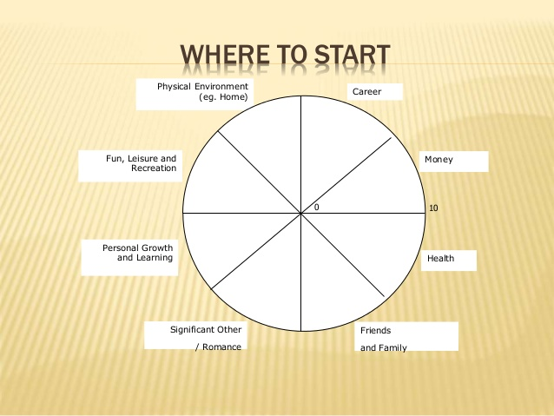
The Wheel of Youth Work
YOUTH WORK THEORIES
ENGAGING AND COMMUNICATING WITH YP
SAFEGUARDING
WORKING WITH GROUPS OF YP
ANTI DISCRIMINATORY PRACTICE
MANAGING CHALLENGING BEHAVIOUR
BEING REFLECTIVE
YOUNG PEOPLE’S DEVELOPMENT
Score between 0-10
Youth work theories =
Anti-discrimination practice =
Managing challenging behaviour =
Being reflective =
Young people’s development =
Working with groups of YP =
Safeguarding =
Engaging and communicating with YP =

EXAMPLE

8

9

7

2

4

5

8

6

Engaing and communicating with YP 8
COMPLETE THE WHEEL:

1. Review the 8 Wheel Categories

2. Next, draw a line across each segment that represents your confidence, knowledge and experience score for each area.

- Imagine the centre of the wheel is 0 and the outer edge is 10
- Choose a value between 1 (very low) and 10 (Very high)
- Now draw a line and write the score alongside (see example below)

IMPORTANT: Use the FIRST number (score) that pops into your head, not the number you think it should be!

Now reflect on your wheel of youth work and think about what learning targets you have for the course.
You may want to include such things as learning more about specific aspects of youth work, or improving your study skills, or organising and managing your time more effectively, or developing specific areas of expertise to use in your youth work practice. Support needs are to do with what you might need in order for you to achieve your target/goal. For instance, gaining more experience may involve looking into volunteer opportunities at other settings or managing your workload for the course may require additional support from a Tutor or your workplace. Planning ahead will give you the best possible chance of achieving this qualification and getting the most out of the course.

Learning Targets/goals | Support needs

Learner Signature……………………………..

Tutor Signature………………………………..

Date………………………………………………

This will help you to provide evidence for Units
Y/506/9232 Reflective Practice in a youth work setting
2.2 Use reflective practice to review own strengths and areas for development.
2.3 Create a development plan with SMART objectives to address personal learning and support needs.
2.4 Implement a development plan to address own learning and support needs.
T/506/9206 Theory of youth work
6.1 Assess personal skills, knowledge, qualities and values required to practice as a youth worker.

